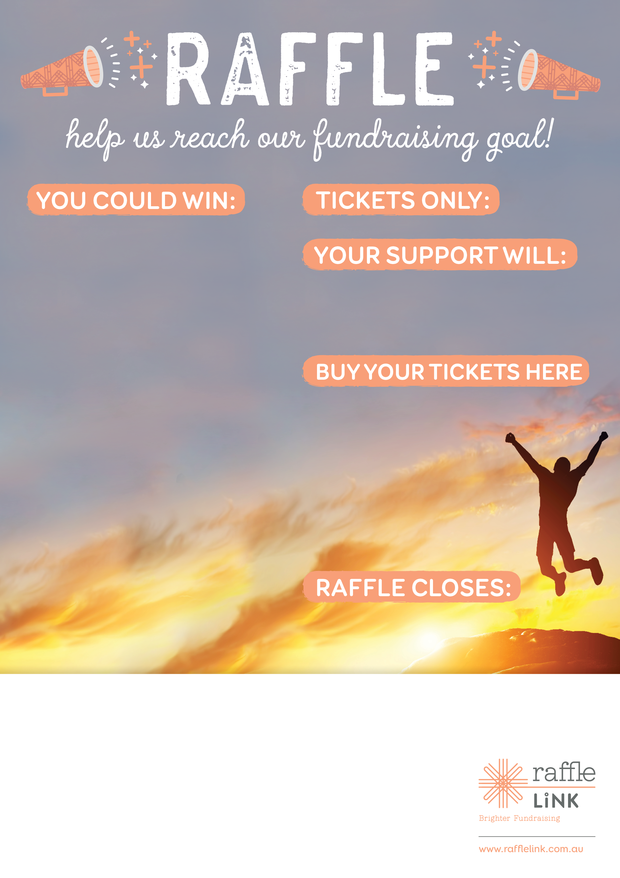

Friday the 11th of June 2015 — 6pm

www.rafflelink.com.au/XYZraffle

Support Blurb

$5

Insert prize package details here i.e.

**1st Prize:**

*Rydes Deluxe Indulgence & Bed & Breakfast Package*

Enjoy 3 nights accommodations for two people in a standard room at any of the 25 Rydges Hotels or Resorts in Australia or New Zealand including a full buffet breakfast daily and a 2 courage a-la-carte dinner with a bottle of house wine. Value: $715

**2nd Prize:**

*Rydes Deluxe Indulgence & Bed & Breakfast Package*

Enjoy 3 nights accommodations for two people in a standard room at any of the 25 Rydges Hotels or Resorts in Australia or New Zealand including a full buffet breakfast daily and a 2 courage a-la-carte dinner with a bottle of house wine. Value: $715

**3rd Prize:**

*Rydes Deluxe Indulgence & Bed & Breakfast Package*

Enjoy 3 night’s accommodations for two people in a standard room at any of the 25 Rydges Hotels or Resorts in Australia or   
New Zealand