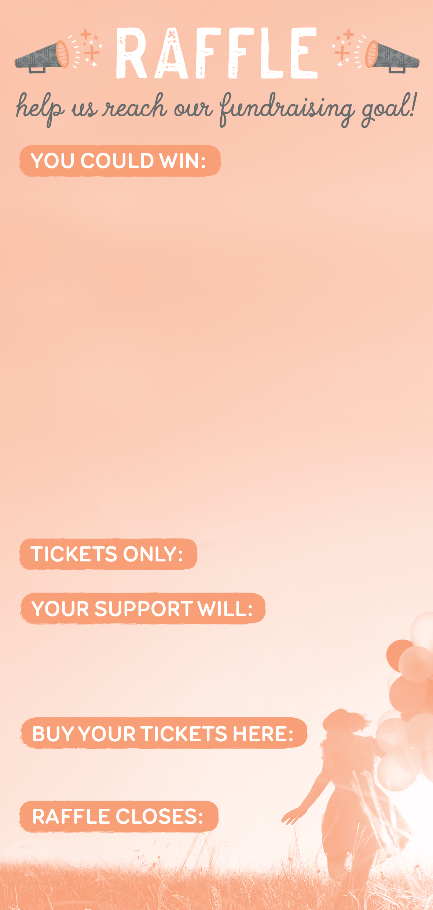

**1st Prize:**

*Rydges Deluxe Indulgence & Bed & Breakfast Package*

Enjoy 3 nights accommodations for two people in a standard room at any of the 25 Rydges Hotels or Resorts in Australia or New Zealand including a full buffet breakfast daily and a 2 courage a-la-carte dinner with a bottle of house wine.

**2nd Prize:**

*Rydges Deluxe Indulgence & Bed & Breakfast Package*

Enjoy 3 nights accommodations for two people in a standard room at any of the 25 Rydges Hotels or Resorts in Australia or New Zealand including a full buffet breakfast daily and a 2 courage a-la-carte dinner with a bottle of house wine.

**3rd Prize:**

*Rydges Deluxe Indulgence & Bed & Breakfast Package*

Enjoy 3 nights accommodations for two people in a standard room at any of the 25 Rydges Hotels or Resorts in Australia.

$5

Support Blurb Line 1  
Support Blurb Line 2  
Support Blurb Line 3

[www.rafflelink.com.au/XYZraffle](http://www.rafflelink.com.au/XYZraffle)

Friday the 11th of June 2015 — 6pm

**1st Prize:**

*Rydges Deluxe Indulgence & Bed & Breakfast Package*

Enjoy 3 nights accommodations for two people in a standard room at any of the 25 Rydges Hotels or Resorts in Australia or New Zealand including a full buffet breakfast daily and a 2 courage a-la-carte dinner with a bottle of house wine.

**2nd Prize:**

*Rydges Deluxe Indulgence & Bed & Breakfast Package*

Enjoy 3 nights accommodations for two people in a standard room at any of the 25 Rydges Hotels or Resorts in Australia or New Zealand including a full buffet breakfast daily and a 2 courage a-la-carte dinner with a bottle of house wine.

**3rd Prize:**

*Rydges Deluxe Indulgence & Bed & Breakfast Package*

Enjoy 3 nights accommodations for two people in a standard room at any of the 25 Rydges Hotels or Resorts in Australia.

$5

Support Blurb Line 1  
Support Blurb Line 2  
Support Blurb Line 3

[www.rafflelink.com.au/XYZraffle](http://www.rafflelink.com.au/XYZraffle)

Friday the 11th of June 2015 — 6pm

**1st Prize:**

*Rydges Deluxe Indulgence & Bed & Breakfast Package*

Enjoy 3 nights accommodations for two people in a standard room at any of the 25 Rydges Hotels or Resorts in Australia or New Zealand including a full buffet breakfast daily and a 2 courage a-la-carte dinner with a bottle of house wine.

**2nd Prize:**

*Rydges Deluxe Indulgence & Bed & Breakfast Package*

Enjoy 3 nights accommodations for two people in a standard room at any of the 25 Rydges Hotels or Resorts in Australia or New Zealand including a full buffet breakfast daily and a 2 courage a-la-carte dinner with a bottle of house wine.

**3rd Prize:**

*Rydges Deluxe Indulgence & Bed & Breakfast Package*

Enjoy 3 nights accommodations for two people in a standard room at any of the 25 Rydges Hotels or Resorts in Australia.

$5

Support Blurb Line 1  
Support Blurb Line 2  
Support Blurb Line 3

[www.rafflelink.com.au/XYZraffle](http://www.rafflelink.com.au/XYZraffle)

Friday the 11th of June 2015 — 6pm